Radfield Home Care is offering you an affordable business opportunity in a growing marketplace...

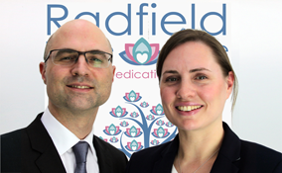
With over 30 years of experience in providing care to the elderly, Radfield Home Care is an award-winning company built on an outstanding reputation, whose director Dr Hannah MacKechnie is a qualified GP.
Hannah, alongside her brother Alex, grew up in Radfield Residential Home for the Elderly giving them a unique insight and knowledge which they have used to establish Radfield Home Care as a leading name in care.

Leading the way in ethical business
Hannah and Alex are committed to growing their business in a way that not only delivers healthy profits but also looks after its people and the environment.
Radfield Home Care is the very first Certified B Corp® in the UK Health Care sector
B Corp is to business what Fair Trade is to coffee and this accolade demonstrates their commitment to working in partnership with their franchisees to develop sustainable businesses that are part of their local community.
We are offering the opportunity to share our unrivalled knowledge and expertise with our franchisees to work together to make Radfield Home Care the elderly care provider of choice across the UK.

The Elderly Care Specialists
The elderly home care marketplace is booming and the rate of growth shows no signs of stopping as people are living longer and looking to remain in their own homes for as long as possible.
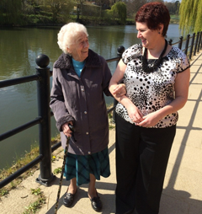
Thanks to their experience the care sector, Radfield’s franchisors identified that, due to the growth in elderly demographic, there was a real opportunity to focus specifically on this market and to deliver a high quality, highly profitable service rather than a broader offering with higher quantity but lower profitability.
At Radfield Home Care, we recognised that we didn’t want to try to deliver all types of care but excel and dominate this particular market. We believe that it is a far more compelling proposition, for a son or a daughter purchasing care for their elderly relative, to choose the care provider who is an expert in their field.
The Radfield Home Care Business Model
Our dedicated teams of carers provide support to elderly people in their own homes, from 30 mins to round-the-clock care, to ensure they can remain living independently for longer at home.
The franchisee will need to run the business and network to grow the client and carer base. They should be committed, passionate and enterprising individuals wanting to build a reputable and successful business with the support of our highly-respected brand. It is not essential to have prior knowledge of the care sector or of running your own business as we can help you develop your skills in these areas.
We partner with the latest technology solutions to run the most cost effective service possible allowing more time for franchisees to devote to the growth of their business and not just the running of it.
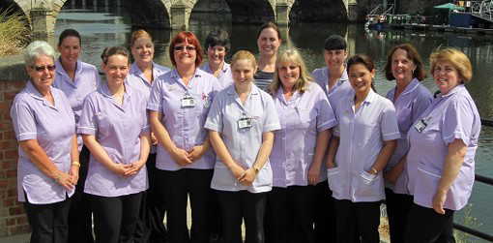

Training and Support
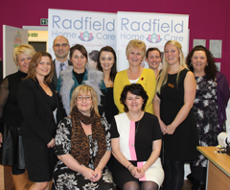
The Radfield Home Care training and support programme is completely dedicated to one objective - ensuring that our franchisees gain the skills and knowledge to dominate their local home care marketplace and build a highly successful business.
We provide our franchisees with an extensive in-depth induction course and ongoing skills-building programme based at head office and at their own location.
Our head office team is highly experienced in the financial, medical, IT, care, traditional and digital marketing, business development and compliance worlds so we can offer each of our franchisees individually tailored support that can accelerate their business success.
The Franchise Package
When you invest in a Radfield franchise, you are awarded an exclusive territory in which there are at least 35,000 elderly people and also a total population exceeding 115,000 people to ensure that there is a sufficient pool of working age people to recruit from.
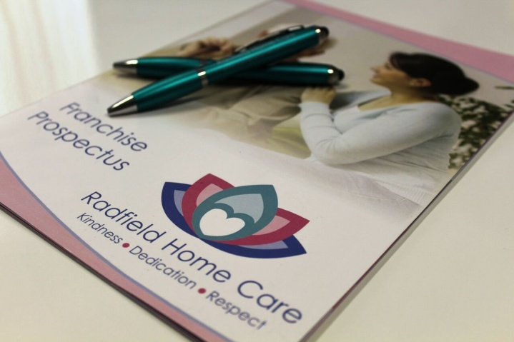
These are larger territories than many other care franchises and as we are an early franchise network there is much opportunity for ambitious franchisees to expand into adjacent territories and build a larger, more profitable business for themselves.
Along with the comprehensive initial training programme, our franchise package also includes:
- Assistance with business planning and finance applications
- A range of marketing materials & branded uniforms
- HR and health & Safety advice and insurance
- Establishment of bespoke technology solutions
- Your own suite of web pages on our fully SEO optimised website
- A dedicated franchise support manager
- Unlimited care, business and marketing support tailored to your specific needs
- A web portal to access documents
- Keeping updated with sector news, policies and changes to legislation
- Payroll services
- A regularly updated operations manual
- Mentoring and networking opportunities

Financials
The cost of a Radfield Home Care Franchise is £25,000 + VAT and working capital of around £31,500 is needed to support the start up phase of the business.
The working capital requirement will be significantly lower if starting the business from home and if you have care management skills within the franchise team.
We have partnered with several banks who are willing to lend money to the right Radfield Home Care franchisees if finance is required.

Could you be our next franchise partner?
We have territories currently available and we are looking for ambitious people to join our franchise network early on who can benefit from this opportunity.
If you feel that you have what it takes to join the Radfield Home Care team and would like to be part of an exciting new franchise then we would love to hear from you.

